SQL For DE - Assignment 1
Section A:
Q1. Order count for each product line where orders are more than 100 (Hint: Use Having)
2).
SELECT p.productLine, COUNT(DISTINCT o.orderNumber) AS total_orders FROM products p
JOIN orderdetails od ON p.productCode = od.productCode
JOIN orders o ON od.orderNumber = o.orderNumber
GROUP BY p.productLine
HAVING COUNT(DISTINCT o.orderNumber) > 100;
3).
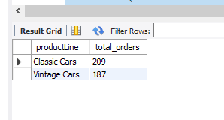
4).
Start with orders which Contains: orderNumber
But it does NOT tell: which products were in the order which product line it belongs to
so we did join with orders --> orderdetails but still no product line
so we did join with orderdetails --> products (product line)
Table What it has
orders order info
orderdetails which products in order
products productLine

Q2. Count of employees against each manager name (Hint: Use Self Join)

SELECT CONCAT(m.firstName, ' ', m.lastName) AS manager_name, COUNT(e.employeeNumber) AS employee_count FROM employees e
JOIN employees m ON e.reportsTo = m.employeeNumber
GROUP BY m.employeeNumber;

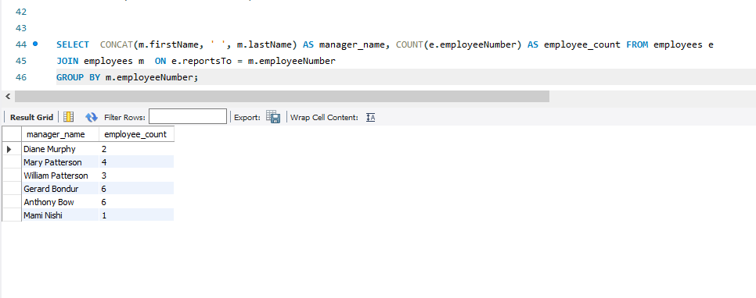

Self join in same table like
all are employees but in employees some reports to manager
each employee has a reportsto -> which is actually their manager’s employeeNumber
e=employee
m=manager

Q3. For each city, create individual columns of order count by each Order Status available
(Hint: Use CASE WHEN to Create Conditional Aggregations)

SELECT c.city,
COUNT(CASE WHEN o.status = 'Shipped' THEN 1 END) AS shipped,
COUNT(CASE WHEN o.status = 'Cancelled' THEN 1 END) AS cancelled,
COUNT(CASE WHEN o.status = 'Resolved' THEN 1 END) AS resolved,
COUNT(CASE WHEN o.status = 'Disputed' THEN 1 END) AS disputed,
COUNT(CASE WHEN o.status = 'On Hold' THEN 1 END) AS on_hold
FROM customers c JOIN orders o ON c.customerNumber = o.customerNumber
GROUP BY c.city;
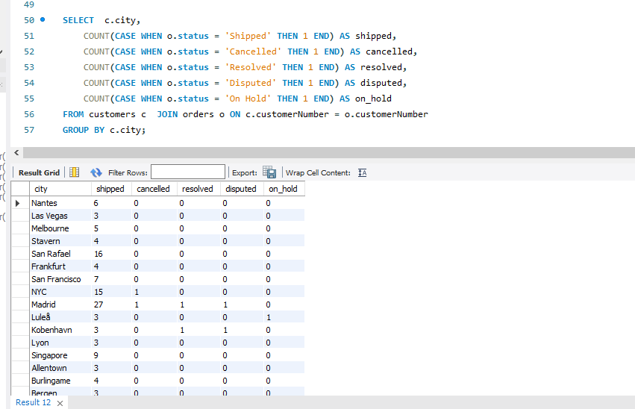

FROM customers c
JOIN orders o ON c.customerNumber = o.customerNumber

customers -> gives city orders -> gives status then

GROUP BY c.city; data row per city

If status = 'Shipped' -> return 1 Else -> return NULL

Q4. For each office total orders sold (Hint: Using Multiple Joins)
SELECT o.officeCode, o.city, COUNT(DISTINCT ord.orderNumber) AS total_orders FROM offices o
JOIN employees e ON o.officeCode = e.officeCode
JOIN customers c ON e.employeeNumber = c.salesRepEmployeeNumber
JOIN orders ord ON c.customerNumber = ord.customerNumber
GROUP BY o.officeCode, o.city;

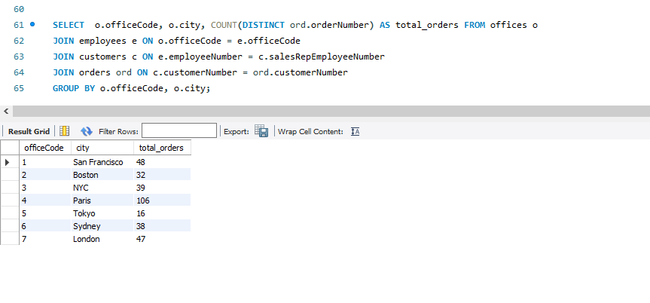
Table Info
offices office info
employees who works there
customers handled by employees
orders placed by customers
We join the offices, employees, customers, and orders tables to connect each office
with the orders placed by its customers.

Each office has employees, employees handle customers, and customers place orders.
We use COUNT(DISTINCT orderNumber) to count total unique orders for each office.
GROUP BY is used to show results for each office separately.

Q5. For each Employee total order sold (Exclude those Employees which are in USA)
(Hint: Use Sub-Query in Where)

SELECT e.employeeNumber, CONCAT(e.firstName, ' ', e.lastName) AS employee_name, COUNT(ord.orderNumber) AS total_orders
FROM employees e
JOIN customers c ON e.employeeNumber = c.salesRepEmployeeNumber
JOIN orders ord ON c.customerNumber = ord.customerNumber
WHERE e.officeCode NOT IN (SELECT officeCode FROM offices WHERE country = 'USA')
GROUP BY e.employeeNumber;

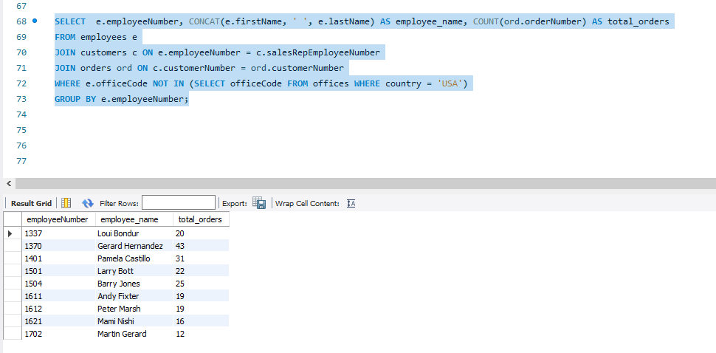

In our we did query joins employees, customers, and orders to count total orders per employee while excluding those working in USA using a subquery.

Q6. 2nd highest selling product for each Productline (Use Window Function & CTE Approach)
WITH product_sales AS (SELECT p.productLine, p.productName, SUM(od.quantityOrdered) AS total_sold FROM orderdetails od
JOIN products p ON od.productCode = p.productCode
GROUP BY p.productLine, p.productName
),
ranked_products AS (SELECT *, DENSE_RANK() OVER (
PARTITION BY productLine
ORDER BY total_sold DESC
) AS rnk
FROM product_sales)
SELECT productLine, productName, total_sold
FROM ranked_products
WHERE rnk = 2;
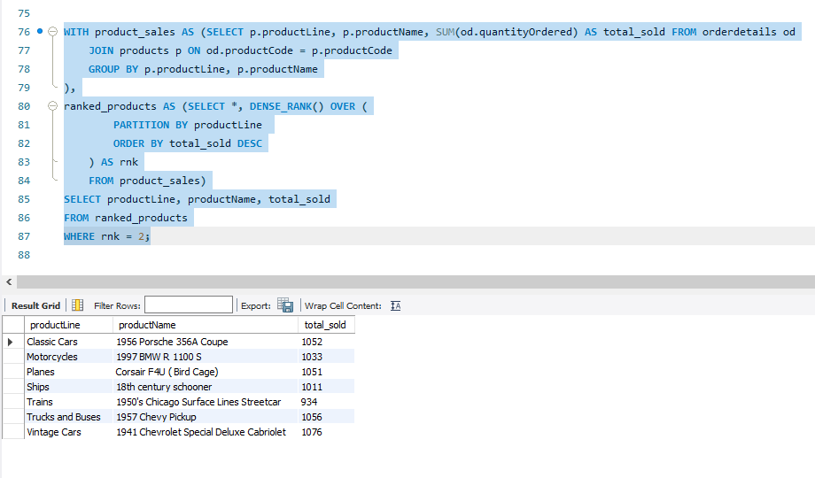
We first use a CTE to calculate total quantity sold for each product within each product line.
Then, a window function DENSE_RANK is used to rank products based on sales within each product line.
Finally, we filter the results to get only the 2nd highest selling product from each product line.

1. Creating a Procedure:
Create a procedure that takes a Date Parameter and uses it to migrate data from Original table to another table for all the Complaints received in Last 6 Months use “date_received” column to replicate data into another table. Name the table as “complaints_last_6_months”
Table to Migrate from: complaints_table_assignment
Table to Migrate to: complaints_last_6_months
USE `mydb`;
DELIMITER $$
CREATE PROCEDURE migrate_last_6_months(IN input_date DATE)
BEGIN
-- Creating table if not exists
CREATE TABLE IF NOT EXISTS complaints_last_6_months
LIKE complaints_table_assignment;

-- Clearing the old data
TRUNCATE TABLE complaints_last_6_months;

-- Insert last 6 months data
INSERT INTO complaints_last_6_months
SELECT *
FROM complaints_table_assignment
WHERE date_received >= DATE_SUB(input_date, INTERVAL 6 MONTH);
END $$
DELIMITER ;

CALL migrate_last_6_months(CURDATE());

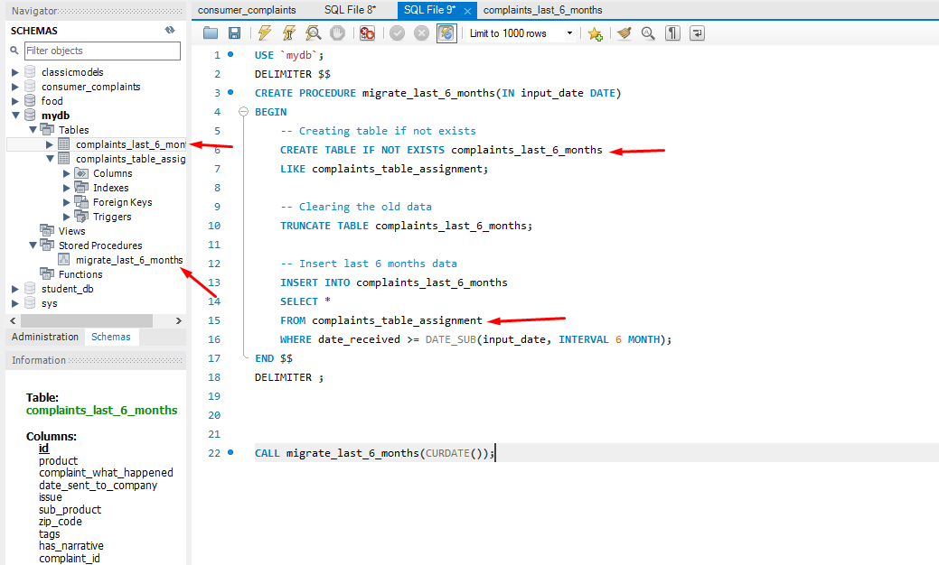

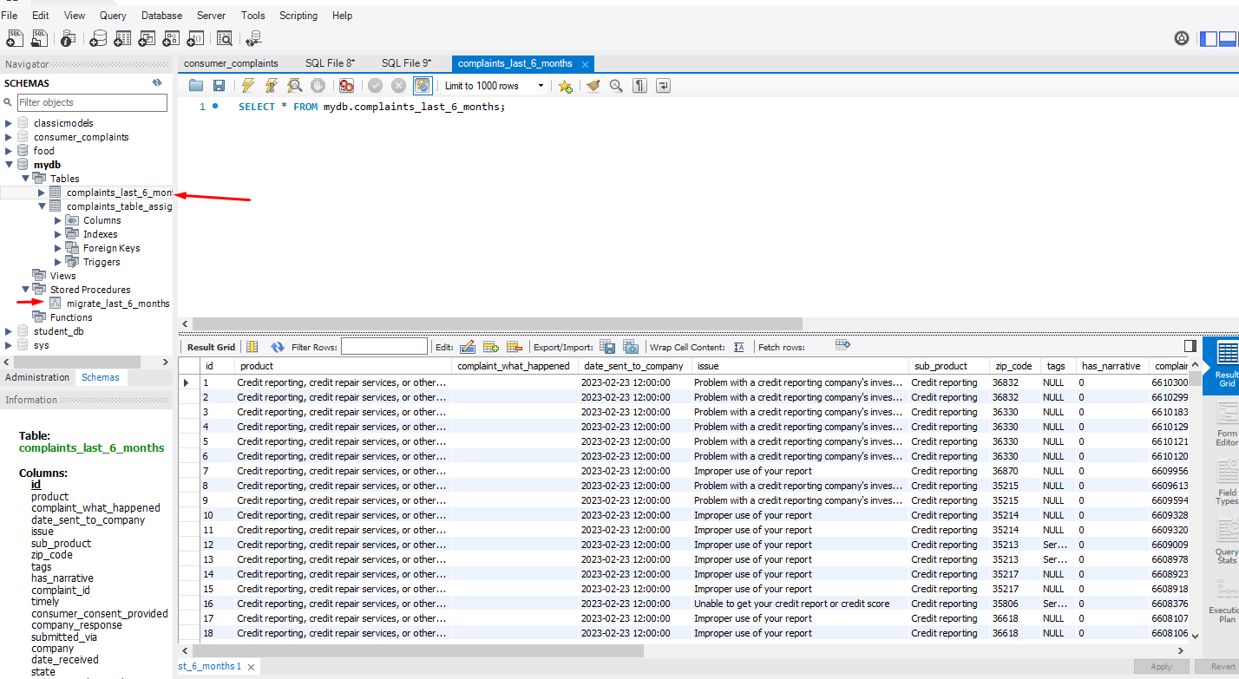

step1:
CREATE PROCEDURE migrate_last_6_months(input_date DATE)
reusable block where you pass a date (like CURDATE())

step2:
Creates a new table if not exists with same structure

step3:

Deletes previous data (fresh start every time)

step4:

Inserting last 6 months data

step5

then Run procedure same like calling functions in python

2. Creating a Trigger and placing over original:
Create a trigger that updates “complaints_last_6_months” table with a new record whenever the data is inserted in complaints_table_assignment table based on the same criteria of Complaints received in Last 6 Months use “date_received” column. (Hint: On Insert trigger will be used)
USE `mydb`;
DELIMITER $$

CREATE TRIGGER trg_after_insert_complaints
AFTER INSERT ON complaints_table_assignment
FOR EACH ROW
BEGIN

IF NEW.date_received >= DATE_SUB(CURDATE(), INTERVAL 6 MONTH) THEN

INSERT INTO complaints_last_6_months
(id, product, complaint_what_happened, date_sent_to_company, issue,
sub_product, zip_code, tags, has_narrative, complaint_id, timely, consumer_consent_provided)
VALUES
(NEW.id, NEW.product, NEW.complaint_what_happened, NEW.date_sent_to_company, NEW.issue,
NEW.sub_product, NEW.zip_code, NEW.tags, NEW.has_narrative, NEW.complaint_id, NEW.timely, NEW.consumer_consent_provided);

END IF;

END $$

DELIMITER ;

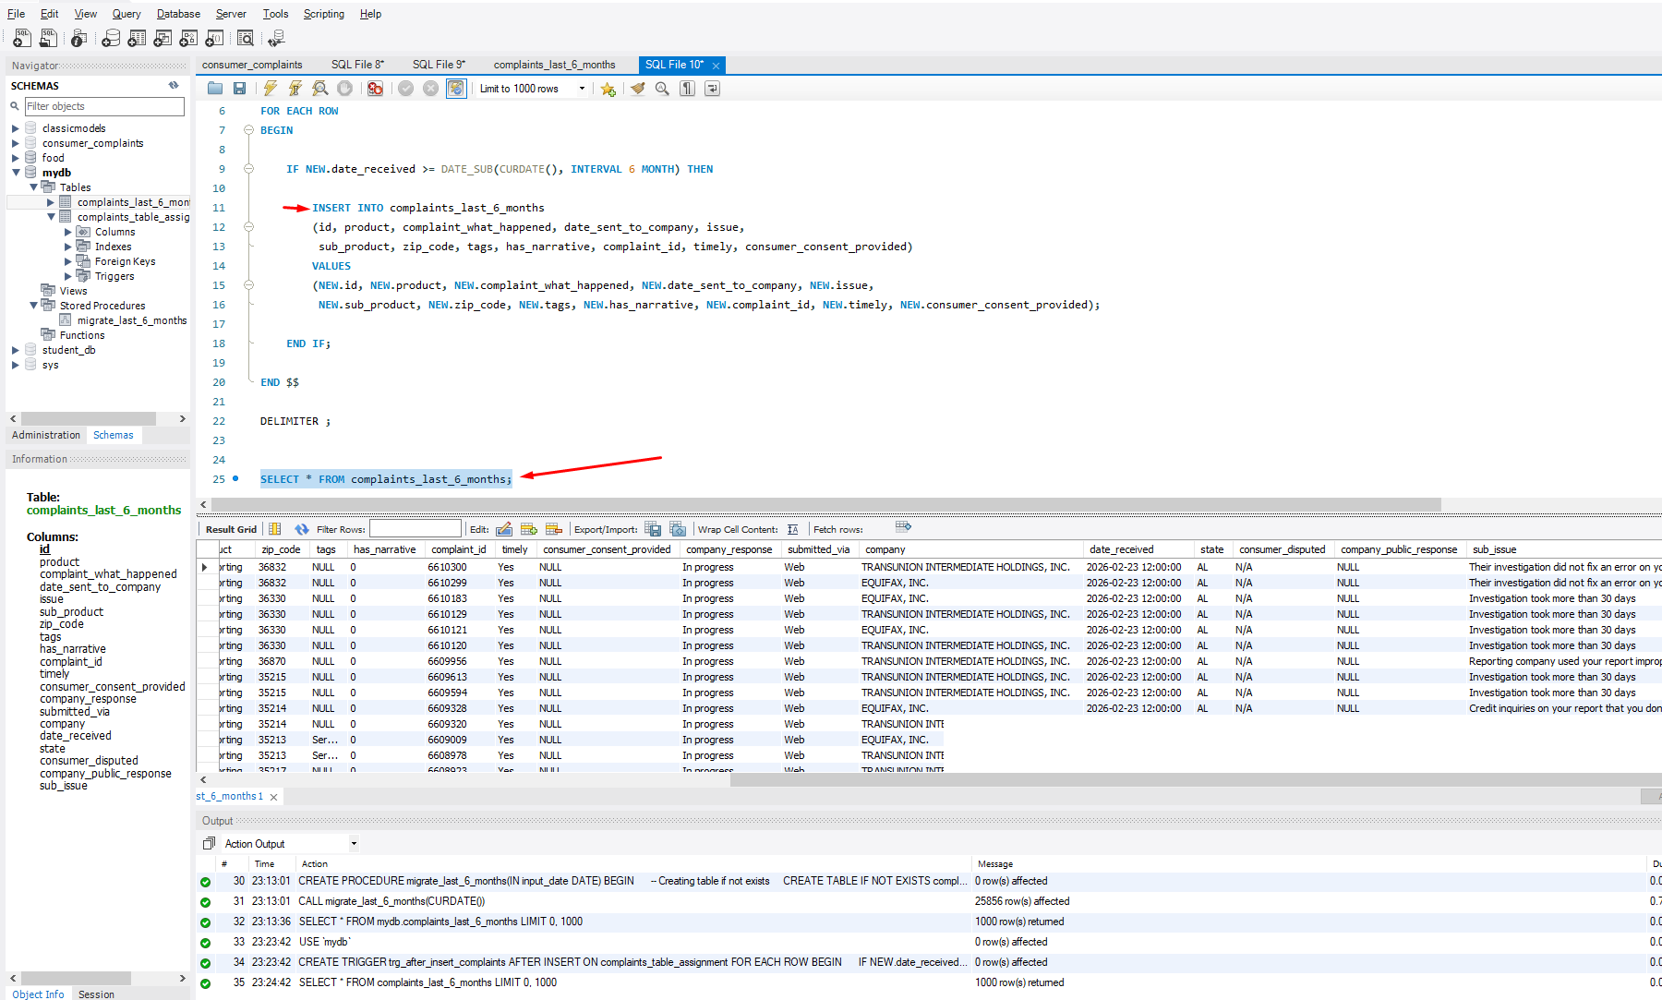

INSERT INTO complaints_table_assignment
(id, product, complaint_what_happened, date_received)
VALUES
(999, 'Test Product', 'Testing trigger', CURDATE());

To check: SELECT * FROM complaints_last_6_months;

Every time a new record is inserted -> trigger runs
AFTER INSERT ON complaints_table_assignment

FOR EACH ROW
Runs for every new record

Condition check
IF NEW.date_received >= DATE_SUB(CURDATE(), INTERVAL 6 MONTH)
Only allows last 6 months data
Insert into target table
Coping new record into reporting table
How it will work:
-----New data comes in
--Trigger checks date
--If valid --> auto copy
--If not --> ignore

3. Creating a View:
The CFPB Webmaster now wants you to show a Treemap Visualization on the Web UI for which as a backend developer wants you to develop a View in Database which shows number of complaints received against each product and sub_product in the last 3 Months.
Create a view product_summary_last_3M over the table “complaints_last_6_months”.
Hint: Make sure to write a query such that the view is dynamic to today’s date so data is always relevant from today’s date up to 3 months back!
Exception: In case you have not been able to do procedure task, then you can create view directly from complaints_table_assignment, reduced marks will be allocated.

USE `mydb`;
CREATE VIEW product_summary_last_3M AS
SELECT product, sub_product, COUNT(*) AS total_complaints FROM complaints_last_6_months
WHERE date_received >= DATE_SUB(CURDATE(), INTERVAL 3 MONTH)
GROUP BY product, sub_product;

To check:
SELECT * FROM product_summary_last_3M;

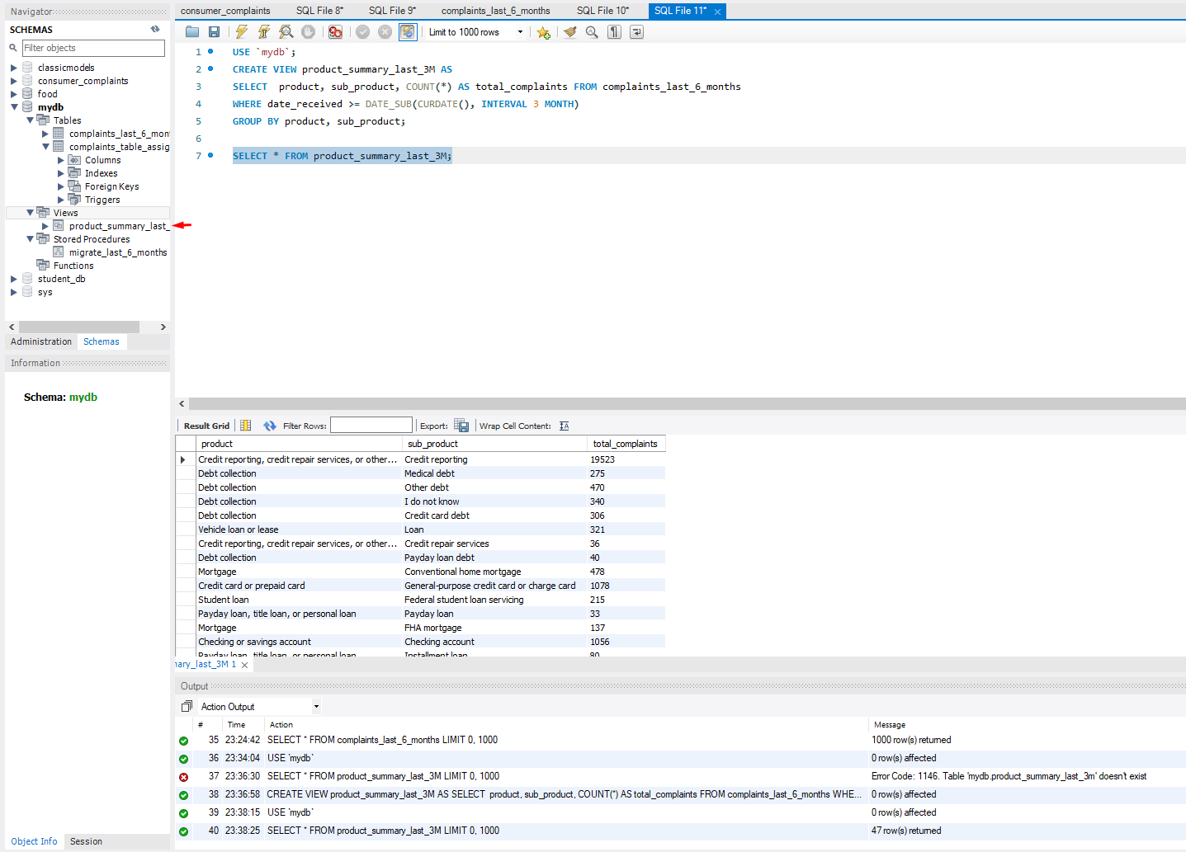

view: product_summary_last_3M
Number of complaints per product & sub-product for last 3 months

Source table: FROM complaints_last_6_months
Using already filtered last 6 months data from procedure

Filter last 3 months
WHERE date_received >= DATE_SUB(CURDATE(), INTERVAL 3 MONTH)
to recent 3 months only

GROUP BY product, sub_product
Combines same product and sub_product -> COUNT(*) AS total_complaints

